Chapter 3
METHODOLOGY
This chapter presents the research design and the systematic process used to develop SmartHub v5: a Windows desktop diagnostic tool for Android phones. It details the selection of respondents, the primary and secondary sources of data, the instruments used for data collection, and the techniques employed for data analysis. Furthermore, this section discusses the development framework utilized to build the system, focusing on the Scrum framework. This iterative approach allows continuous refinement of technician workflows such as ADB-based diagnostics, USB-only/no-debug triage for blue/blank/broken-screen devices, and evidence-based reporting, ensuring that the final application meets operational requirements while maintaining high levels of development efficiency and adaptability. The primary stakeholder locale for this project is Carlo Gadget Repair Shop and Accessories.
This chapter outlines the technical framework and procedural steps taken to build SmartHub v5 as an offline-first diagnostic workstation tool. It provides a comprehensive overview of requirements gathering, architectural design, implementation strategies, and the specific tools used to validate the system's performance. To ensure the final product is both technically sound and operationally relevant, the project uses a hybrid approach combining descriptive and developmental research. The descriptive component is used to document and evaluate existing diagnostic practices (including the limitations of no-USB-debugging cases), while the developmental component governs the actual engineering of the solution, including local evidence collection and optional offline analysis. To maintain adaptability throughout the build, the Scrum framework is implemented. This allows the development team to refine features such as connection stability checks, no-debug triage, and report generation through continuous feedback loops and incremental updates.

3.1 Requirement Analysis
The project's methodology outlines the steps, data sources, tools, and data collection techniques that guide the development of SmartHub v5. In system and software engineering, requirements analysis involves identifying and understanding the needs that a diagnostic application must meet while also balancing the sometimes-conflicting priorities of various stakeholders, including technicians, support personnel, and device owners. This process includes thorough analysis, documentation, validation, and continuous requirements management to ensure the system remains technically sound and user-focused.
For SmartHub v5, the system requirements are clear, actionable, measurable, and aligned with the project's goal to produce technician-ready results supported by evidence. After collecting relevant information from stakeholders, the developers closely examine current diagnostic challenges, specifically the inefficiencies caused by fragmented evidence capture, intermittent USB behavior, and the difficulty of diagnosing blue/blank/broken-screen devices when USB debugging is unavailable.
At the same time, the developers envision a system that streamlines these manual tasks through a unified offline-first workstation interface, automated evidence collection via ADB/Fastboot when available, USB-only stability sampling when ADB is not available, and clear next-step guidance. Throughout the development process, all requirements are carefully reviewed and validated to ensure the final system directly addresses these gaps and remains within explicit safety boundaries (no security bypass claims, no remote enabling of USB debugging, and no exploit workflows).
At present, many troubleshooting activities rely on a mix of manual checks and ad-hoc tool usage. In no-debug cases, technicians often depend on inconsistent observations and lack standardized evidence. To address these issues, the development team conducts an in-depth assessment of existing workflows by observing diagnostic steps and interviewing intended users. The findings reveal key challenges, including unstructured record-keeping of evidence, limited visibility into device state, and difficulty reproducing intermittent problems.
These findings directly influence the design and functionality of SmartHub v5. The system is envisioned to provide a structured diagnostic summary with evidence (checks and reasons), confidence-aware conclusions, and recommended next actions. By replacing fragmented tools and manual notes with an integrated offline-first platform tailored to diagnostic workflows, SmartHub v5 aims to minimize errors and reduce diagnostic time.

3.1.1 Population and Locale of the Study
The participants of this project consist of primary stakeholders who perform Android phone diagnostics using a Windows workstation. This group is composed of technicians and support personnel who use diagnostic tools daily. The developers use purposive sampling to select these individuals, as their daily interaction with diagnostic workflows provides the necessary firsthand insights into existing procedural difficulties and evidence collection gaps. In this study, these stakeholders are drawn from Carlo Gadget Repair Shop and Accessories.
The study is centered in a Windows-based diagnostic workstation environment at Carlo Gadget Repair Shop and Accessories (e.g., the service counter/repair area) where Android devices are connected via USB for inspection and evidence collection. This locale is ideal for evaluating an offline-first application that integrates local UI, a local companion service, and local device tooling.
To assess usability and user acceptance, the researchers may apply purposive sampling to a small group of intended users who run representative diagnostic scenarios and evaluate the system based on the ISO/IEC 25010 instrument.

3.1.2 Data Instrumentation
The project uses semi-structured interviews, document/tool analysis, direct observation, internet research, and ISO/IEC 25010 as the main tools for collecting data. These instruments help the developers identify current issues, user needs, and system requirements for SmartHub v5.
Semi-Structured Interview Guides. Qualitative data is primarily gathered through semi-structured interviews with technicians and support personnel. This flexible conversational format allows the researchers to ask prepared questions about operational challenges such as device detection, ADB availability, USB instability, and blue/blank-screen triage while leaving room for follow-up inquiries.
Document and Tool Analysis. To ensure the digital system mirrors necessary real-world evidence, the researchers perform an analysis of available diagnostic artifacts and signals (e.g., ADB outputs, Fastboot information, Windows USB enumeration). This analysis informs the design of read-only checks, local history logs, and the formatting of evidence shown to users.
Direct Observation. The researchers conduct on-site or controlled-environment observations of the diagnostic workflow. This provides first-hand insight into common failure modes and evidence capture practices, ensuring the SmartHub v5 interface is optimized for actual use and supports consistent diagnostic conclusions.
ISO/IEC 25010
ISO/IEC 25010 is a standard created by the International Organization for Standardization (ISO) and the International Electrotechnical Commission (IEC) to evaluate software quality. It provides a model for checking and improving software quality through different characteristics and sub-characteristics, including security and compatibility.
The instrument based on ISO/IEC 25010 serves as a tool to measure how acceptable SmartHub v5 is. It evaluates how well the software meets user expectations and needs based on factors such as functionality, performance, usability, and reliability. By including this evaluation, the developers ensure that the system meets technical standards, provides a good user experience, and maintains high reliability-supporting technician workflows for Android diagnostics.
To quantify these results, a Five-Point Likert Scale is utilized as the primary data collection tool. Using a scale ranging from 5 (Strongly Agree) to 1 (Strongly Disagree), the researchers gather perspectives on evidence clarity, speed, usefulness of suggested next steps, and overall usability.
Internet Research
Before developing SmartHub v5, internet research is used to collect secondary data and study existing tools and practices related to Android diagnostics, ADB/Fastboot utilities, and offline-first workstation design. During this process, scholarly articles, documentation, and technical guides are reviewed. The goal is to learn effective practices and common diagnostic features that can be applied to the project while maintaining safe, evidence-based outputs.

3.2 Computer Hardware and Software Requirement
This part shows an overview of the basic hardware and software requirements needed to run SmartHub v5.
Table 3.2 Hardware and Software Requirements
Category | Requirement
Hardware | Windows 10/11 PC; at least 8 GB RAM; stable USB ports; data-capable USB cable; Android device(s) for testing; optional webcam for screen-visual checking
Software (Runtime) | .NET Desktop Runtime (WPF); Microsoft Edge WebView2 Runtime; Node.js; Android platform-tools (ADB/Fastboot); Python 3 for optional offline helpers
Connectivity | Not required for core operation (local-only). Remote access is disabled by default and should only be enabled explicitly in controlled environments

3.3 Software Requirements for System Development
The development of the system involved a range of tools and technologies that were chosen to ensure efficient performance and functionality. The following software and applications were used:
WPF + WebView2 - The Windows desktop host used to package and run the diagnostic UI reliably on Windows.
HTML/CSS/JavaScript - Used to create the user interface and interactive diagnostic flows.
Node.js + Express + TypeScript - Used to build the local companion service and REST endpoints for diagnostics (localhost:3333).
JSON - Used as the data-interchange format between the UI and the local service.
SQLite - Used as the embedded local database for offline AI memory (memory.sqlite) and ADB AI memory (adb_ai_memory.sqlite).
Android platform-tools (ADB/Fastboot) - Used to collect device information and evidence when USB debugging is available, and to gather limited signals in other modes.
Python 3 (optional) - Used for offline-only helpers such as webcam-based screen analysis and offline AI suggestion/scoring for no-debug cases.

3.4 System Framework
In this project, the system framework presents the structured process undertaken to design, develop, and evaluate SmartHub v5. The framework serves as a guide in organizing the activities involved in system development, from requirement analysis up to system implementation and evaluation. It ensures that the development process follows a systematic and organized approach aligned with the objectives of the study.
The development of SmartHub v5 adopts the Scrum approach, a system development methodology that emphasizes iterative development, continuous collaboration, and frequent feedback from stakeholders. This approach allows the developers to divide the system into smaller functional components and develop them in short cycles called sprints. Through this method, system features such as device detection, ADB diagnostics, no-debug connection checks, optional visual checks, and offline evidence history are gradually developed, tested, and improved.
Scrum is suitable for this project because the system involves multiple diagnostic modes and real-world device variability. Each mode requires continuous refinement of system checks and user messaging. The iterative nature of Scrum ensures the system remains flexible and adaptable to changes, while also allowing improvements based on feedback gathered during development.
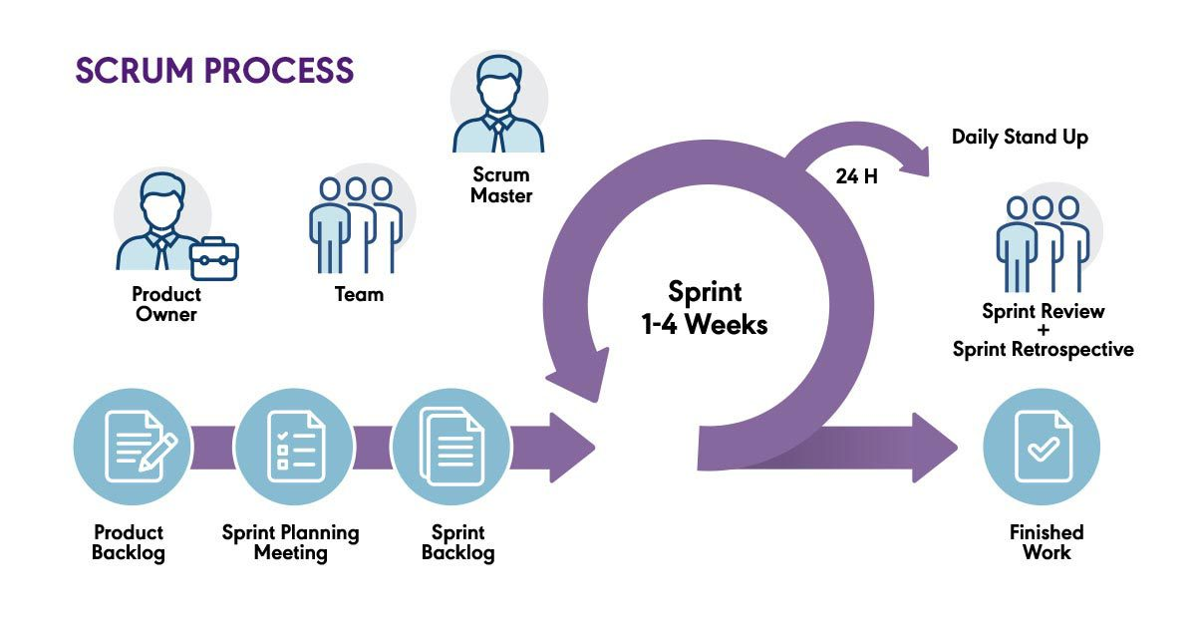Figure 3.4.1 Scrum Development Framework
Figure 3.4.1 illustrates the Scrum Development Framework used in the development of SmartHub v5. This framework highlights the step-by-step process followed by the researchers in building the system, ensuring that all required diagnostic features are properly implemented and evaluated.
Phases of the Scrum Approach
Product Backlog - Identify and list the required features and diagnostic checks (ADB evidence collection, USB-only stability sampling, screen-visual checks, offline AI suggestion, and local history).
Sprint Planning - Select backlog items for a sprint, define tasks and acceptance criteria based on evidence correctness and safety boundaries.
Sprint Development - Design and develop core modules across the UI and backend, integrate local tooling, and perform continuous testing.
Sprint Review - Present and test developed features to determine if they meet required specifications; gather feedback on performance and usability.
Sprint Retrospective - Review the development process and identify areas for improvement in future sprints.
System Deployment - Prepare the application for offline workstation use and validate that dependencies and local-only security constraints are met.
To further illustrate the structure and processes of the system, modeling tools are used. These include Data Flow Diagrams (DFD), Use Case Diagrams, and Entity-Relationship Diagrams (ERD). These tools provide a clear visualization of how data flows within the system, how users interact with the application, and how different data entities are related.

3.5 Tools for Data Analysis - Data Flow Diagram, Use Case, ERD
Data Flow Diagram

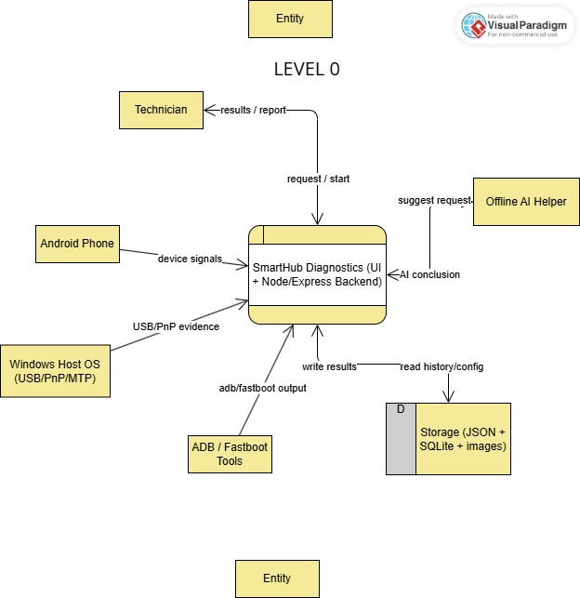
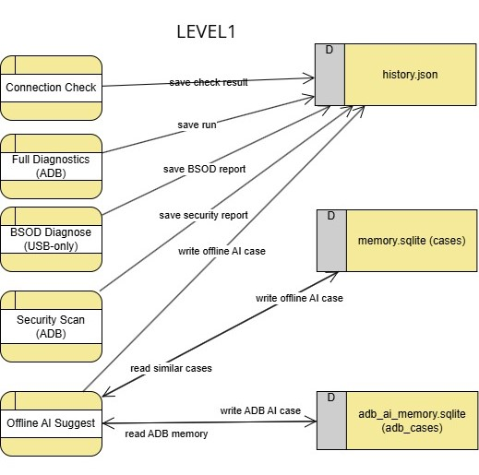
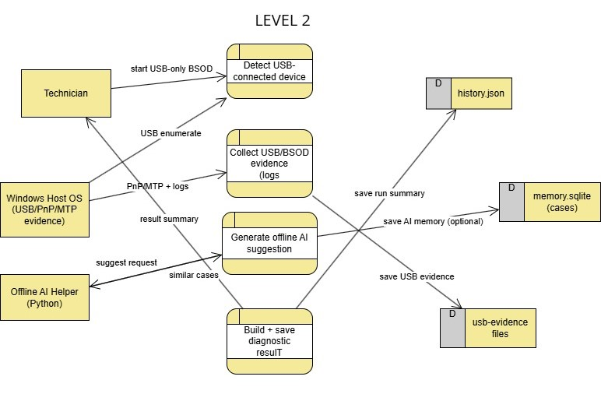
The Data Flow Diagram (DFD) serves as an essential tool in process analysis and system design to illustrate how data flows within SmartHub v5. It helps both the development team and stakeholders visualize the movement of data from input through processing to output, simplifying complex integrations (UI, local API, and ADB/Fastboot/Python helpers).
Developers use DFDs as a bridge between technical implementation and stakeholder understanding. By visualizing how data moves across processes, the researchers identify bottlenecks, inefficiencies, or potential safety issues that might be missed in textual documentation.

Use Case Diagram
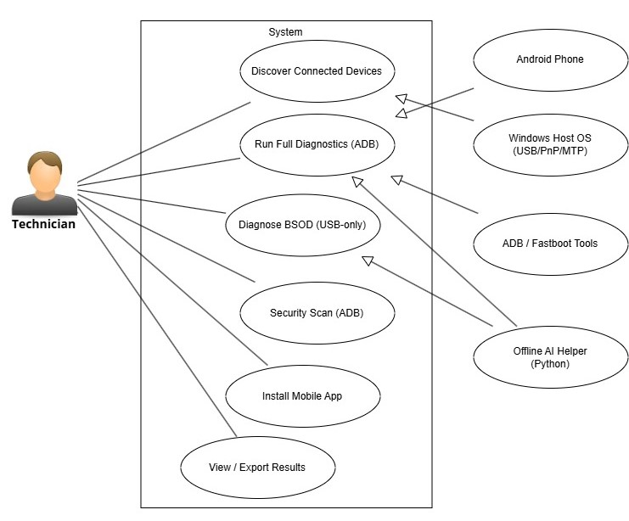
Use Case Diagrams define interactions between actors (technician/support staff) and the system (run diagnostics, collect evidence, review results, save history, and obtain next actions).

Entity-Relationship Diagram (ERD)
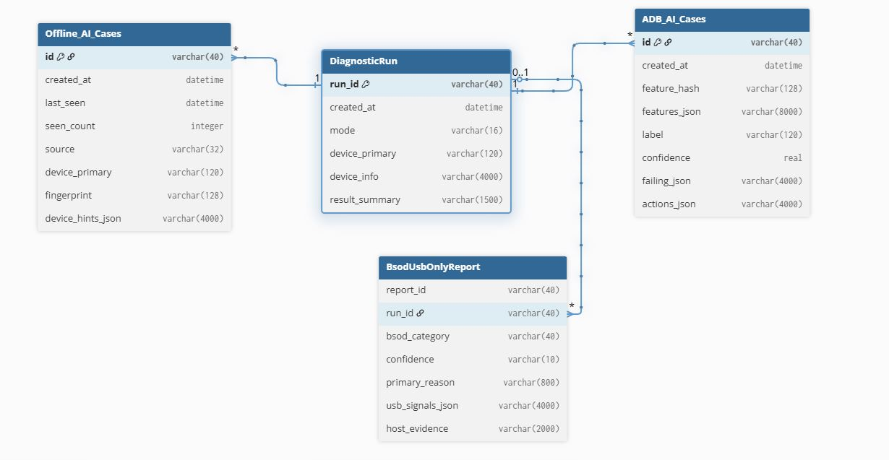
ERDs define how diagnostic runs and evidence are stored locally, including device identifiers, timestamps, collected signals, and conclusions.

3.6 The Proposed Implementation
Planning Phase: Identify and document the needs and expectations of stakeholders and define scope and requirements.
Designing Phase: Create a high-level architecture (WPF WebView2 shell + local web UI + local Node/Express service) and design data structures and interfaces.
Development (Coding) Phase: Implement endpoints, UI flows, ADB/Fastboot integration, and optional offline Python helpers.
Testing Phase: Conduct integration testing, system testing, and user acceptance testing using representative diagnostic scenarios, including no-debug cases.
Deployment Phase: Deploy the tool in an offline workstation environment, ensuring local-only security defaults and correct dependency setup.
Review (Maintenance) Phase: Fix issues, release updates, and refine evidence collection and messaging based on feedback and local history outcomes.

3.7 Statistical Tools
Statistical analysis provides the mathematical framework necessary to interpret the data collected during the system evaluation phase. In this project, these tools are used to analyze feedback from the ISO/IEC 25010 evaluation survey.
The mathematical formula for the weighted average mean is shown below.
Weighted Mean = (Σ(w × x)) / Σw
Where: w = weight assigned to each value; x = each individual response/frequency; Σ = summation.
The developers use the weighted arithmetic mean to determine the average response for each item based on the five (5) options in the questionnaire: 5 (Very Satisfied), 4 (Satisfied), 3 (Neutral), 2 (Unsatisfied), and 1 (Very Unsatisfied).

Table 2.3 Scales and Points of the Questionnaire Survey
Scale | Points
Very Satisfied | 5
Satisfied | 4
Neutral | 3
Unsatisfied | 2
Very Unsatisfied | 1

Table 2.4 Range of the Weighted Mean and its Interpretation
Range of Weighted Mean | Interpretation
4.21 - 5.00 | Respondents are Very Satisfied with the system overall result.
3.41 - 4.20 | Respondents are Satisfied with the system overall result.
2.61 - 3.40 | Respondents are Neutral with the system overall result.
1.81 - 2.60 | Respondents are Unsatisfied with the system overall result.
1.00 - 1.80 | Respondents are Very Unsatisfied with the system overall result.

3.8 Network Diagram
A network diagram serves as a visual representation of how devices and systems interact and exchange data within a digital environment. For this study, the diagram illustrates a local-only architecture, showing how SmartHub v5 connects its users and technical components through localhost communication.

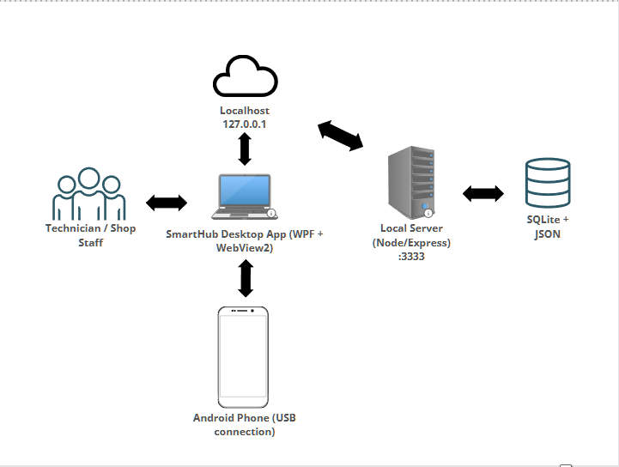
Figure 3.8.1 Network Diagram
Figure 3.8.1 illustrates the SmartHub v5 workstation architecture. The technician uses the Windows desktop shell (WPF + WebView2) to access the diagnostic UI. The UI communicates with the local companion service through localhost, which processes requests and interacts with local tools (ADB/Fastboot) and optional offline Python helpers. The service stores diagnostic results locally (history logs) to support evidence retention and review. This interconnected structure ensures an offline-first and secure workflow for Android phone diagnostics.

